PROJECT DEVELOPMENT PHASE
India's Agricultural Crop Production Analysis (1997-2021)
A Tableau Dashboard built as part of the SmartBridge Data Analytics using Tableau Internship
College | Sri Venkateswara College of Engineering, Tirupati
Department | Artificial Intelligence and Machine Learning
Internship | Data Analytics using Tableau
Academic Year | 2025 - 2026
Team Lead | Shaik Imamkhasim
Team Member | Balaji Veligandla
Team Member | Varada Veera Manoj

1. Project Development Overview

Development Process
The project was developed following an iterative, sprint-based approach. Work began with collecting and understanding the raw agricultural dataset, followed by data cleaning and validation in Excel before the file was connected to Tableau Desktop. Once the connection was stable, individual visualizations were built one at a time - starting with the KPI cards, then the India map, followed by the trend charts and comparison charts. Once every chart was working correctly on its own, the team combined them into a single dashboard, added dashboard actions for interactivity, and finally built a Tableau Story to walk a viewer through the key findings before publishing everything to Tableau Public.

Development Objectives
- Build a single, interactive dashboard that summarizes 24 years of Indian agricultural production data.
- Allow a user to explore production and yield trends by state, year, season, and crop without writing a single formula.
- Present the data visually so that patterns like leading states or seasonal contribution are obvious at a glance.
- Practice real-world Tableau skills - calculated fields, dashboard actions, map visualizations, and story points - within a real internship deliverable.
- Publish the finished work on Tableau Public so it can be shared and viewed by anyone with the link.

Why Tableau Was Selected
Tableau was chosen over spreadsheet-based reporting or a custom-coded dashboard because it lets a small student team build a genuinely interactive, map-based dashboard in a short time frame without any backend development. Its drag-and-drop interface made it easy to prototype charts quickly, its built-in geographic roles made plotting Indian states straightforward, and dashboard actions let the team add cross-filtering (as seen when a state is selected on the map) without writing any JavaScript. Tableau Public also gave the team a free, shareable hosting option, which mattered since this was a student project with no dedicated server.

Expected Outcome
The expected outcome was a published, single-screen dashboard covering nine visualizations - two KPI cards and seven charts/maps - supported by an interactive story that explains the main insights in sequence. By the end of the project, the dashboard needed to let a reviewer click any state and instantly see that state's production figures reflected across every other chart, which is exactly what the final published dashboard achieves.

2. Dataset Description
The dataset used for this project captures agricultural crop production across India from 1997 to 2021. Each row represents the production of a particular crop in a particular district, season, and year. The dataset was sourced as an Excel file and contains the following eight columns:

Column Details
- State - the Indian state where the crop was grown, used for the India map and state-wise comparisons.
- District - the specific district within the state, used to keep the dataset granular before aggregation.
- Crop - the name of the crop cultivated (for example rice, wheat, sugarcane, cotton).
- Season - the cropping season in which the crop was grown, such as Kharif, Rabi, Summer, or Whole Year.
- Year - the agricultural year of record, ranging from 1997-98 through 2020-21.
- Area - the cultivated land area for that crop, recorded in hectares.
- Production - the total quantity produced, recorded in the crop's native unit (tonnes, bales, or nuts depending on the crop).
- Yield - the productivity measure, calculated as production per unit of cultivated area.

Sample Dataset
State | District | Crop | Season | Year | Area (Ha) | Production | Yield
Kerala | Kozhikode | Coconut | Whole Year | 2019-20 | 85,420 | 129.92B (Nuts) | 1,521
Uttar Pradesh | Meerut | Sugarcane | Kharif | 2018-19 | 212,340 | 4.58B (Tonnes) | 21.6
Tamil Nadu | Coimbatore | Cotton | Kharif | 2015-16 | 48,760 | 987.1M (Bales) | 20.2
Andhra Pradesh | Guntur | Rice | Rabi | 2012-13 | 63,110 | 19.2B (Tonnes) | 30.4
Karnataka | Mysuru | Ragi | Kharif | 2009-10 | 31,540 | 310.8B (Nuts) | 9.9
Table: Representative sample rows from the Agricultural Crop Production dataset (1997-2021).

3. Data Preparation

Importing the Excel Dataset
The raw dataset was maintained as an .xlsx file and connected to Tableau Desktop using Tableau's native Excel connector. The connector automatically read the sheet, detected column headers, and loaded every row into Tableau's in-memory data engine, which made the subsequent drag-and-drop chart building possible.

Checking Missing Values
Before trusting any chart, the team scanned the Area, Production, and Yield columns for blanks and zero-filled rows. A handful of district-level rows with missing Production values were identified and removed, since keeping them would have understated state totals on the map and KPI cards.

Checking Data Types
Tableau's automatically assigned data types were reviewed one by one: Year was kept as a discrete field so it plots correctly on axes and filters, Area/Production/Yield were confirmed as numeric (decimal) measures, and State/District/Crop/Season were confirmed as text (string) dimensions so they could be used for grouping and the map's geographic role.

Data Validation
Row counts in Tableau were cross-checked against the row count of the original Excel sheet to confirm that nothing was silently dropped during the import. A few sample totals were also manually recalculated in Excel using SUM formulas and compared against Tableau's aggregated values to confirm the numbers matched.

Column Verification
Every column name was checked for consistent spelling and formatting - trailing spaces and inconsistent capitalization (for example 'kerala' vs 'Kerala') were corrected so that grouping and filtering worked reliably across the whole dataset.

Data Cleaning
Duplicate rows, caused by the same crop/district/year combination appearing twice in the source file, were removed. State names were standardized to match Tableau's built-in geographic role for India, which was essential for the map to plot every state correctly instead of leaving some states blank.

Data Consistency
Finally, the team verified that every state appearing in the dataset also appeared correctly on the map, that year values followed a consistent format across all 24 years, and that unit types (tonnes, bales, nuts) were kept distinct in the Production Distribution by Unit Type chart rather than being incorrectly summed together.

4. Business Questions
The dashboard was designed to answer the following business questions, each of which maps directly to one or more of the visualizations built in Tableau:
- Which state has recorded the highest total agricultural production between 1997 and 2021?
- Which state has the largest total cultivated area, and how does that compare with its production?
- How has India's total agricultural production changed year-over-year across the 24-year period?
- What is the overall trend in agricultural yield from 1997 to 2021 - is productivity per hectare improving?
- Which season (Kharif, Rabi, Summer, or Whole Year) contributes the maximum share of total production?
- Which unit type (tonnes, bales, or nuts) accounts for the largest share of total national production?
- Which are the top five leading agricultural states, and how large is the gap between the leader and the rest?
- Does a state with a large cultivated area always translate into high production, or do smaller states outperform on yield?
- How does selecting a single state change the read of production distribution and season-wise contribution for that state alone?
- Which years experienced a dip or plateau in production, and can any pattern be seen around those years?
- What is the relationship between total yield and total production at the national level?
- How can a policymaker or agri-business use this dashboard to quickly identify which state to focus resources on?

5. Dashboard Development
With every individual chart validated, the next step was to combine them into one cohesive dashboard, titled 'Comprehensive Analysis of Agricultural Production in India (1997-2021)'.

Dashboard Theme
A soft cream-and-green color palette was chosen so the visuals stay easy on the eye across a large screen: cream/beige panel headers separate each chart clearly, while green shades on the map and story elements reinforce the agricultural theme of the project.

Layout and Containers
The dashboard is arranged using horizontal and vertical containers so every chart resizes proportionally. The top row holds the India map, the year-wise production bar chart, and the yield trend line chart side by side, with the two KPI cards (Total Production and Total Yield) stacked in a container on the far right. The bottom row holds the cultivated area bar chart, the production distribution donut chart, the leading states bar chart, and the season-wise pie chart, again arranged in equal-width containers.

Interactive Design, KPI and Map Placement
The two KPI cards were deliberately placed top-right, since that is the natural place a viewer's eye lands after reading the title, giving an immediate headline number before they explore the detailed charts. The India map was placed top-left as the dashboard's primary navigation tool - it is the chart most users click first, and its position as a dashboard action source made it natural to place it prominently.

Charts Arrangement
Charts were grouped by theme: production-over-time charts (bar and line) sit together in the top row next to the map, while comparison and distribution charts (area, donut, leading states, season) sit together in the bottom row. This keeps related questions - 'how has production changed' versus 'how is production distributed' - visually grouped for the viewer.
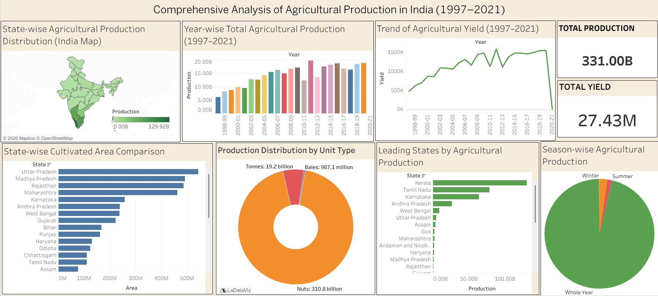
Figure 1: Published dashboard - Comprehensive Analysis of Agricultural Production in India (1997-2021).

6. Dashboard Visualizations
The finished dashboard contains nine visual elements. The table below explains the purpose of each and the key insight it delivers.
Visualization | Purpose | Insights
Total Production KPI | Show the national aggregate production figure at a glance. | Total production stands at 331.00B units across all crops and years, giving an immediate headline figure.
Total Yield KPI | Show the national aggregate yield figure at a glance. | Total yield of 27.43M reflects overall productivity per cultivated hectare across India.
India Map | Plot state-wise production geographically using color intensity. | Southern states, especially Kerala and Tamil Nadu, show the darkest shading, indicating the highest production.
Year-wise Production | Track how national production has moved year by year. | Production shows a broadly rising trend from 1998 to 2021, with a few years of flatter growth.
Agricultural Yield Trend | Track productivity per hectare over the same 24-year period. | Yield improved steadily through the study period with small year-to-year fluctuations.
State-wise Cultivated Area | Compare how much land each state farms. | Uttar Pradesh, Madhya Pradesh, and Rajasthan have the largest cultivated areas.
Production Distribution by Unit Type | Break total production down by measurement unit. | Tonnes make up the overwhelming majority of production, with bales and nuts as smaller shares.
Leading Agricultural States | Rank states by their total production. | Kerala leads by a wide margin, followed by Tamil Nadu and Karnataka.
Season-wise Production | Show how production splits across cropping seasons. | The Whole Year season contributes the overwhelming majority of production, with Winter and Summer contributing much smaller shares.

Figure 2: Full dashboard view showing all nine visualizations arranged together.

7. Dashboard Actions
To make the dashboard genuinely interactive rather than a static report, a dashboard action was configured on the India map so that clicking any state filters every other chart on the dashboard to that state's data.

Dashboard Actions and Cross Filtering
A 'Filter' action was set up with the India map as the source sheet and every other chart on the dashboard as target sheets. When a state is clicked, Tableau automatically applies that state as a filter across the whole dashboard, which is what is commonly called cross filtering.

Interactive Analysis and Keep Only
The screenshot below shows the state of Kerala selected on the map, with the right-click context menu displaying 'Keep Only' and 'Exclude' options alongside the tooltip that reports Kerala's exact production figure (129.92B). Selecting Keep Only locks the whole dashboard to Kerala's data only, while Exclude would remove Kerala and recalculate every chart for the remaining states.

Dynamic Filtering and What Happens When Kerala Is Selected
Once Kerala is selected, the Total Production and Total Yield KPI cards recalculate to show Kerala's numbers alone, the cultivated area bar chart collapses to a single Kerala bar, the donut chart re-scales to show Kerala's unit-type split, the leading states chart isolates Kerala, and the season-wise pie chart updates to reflect only Kerala's seasonal production. Every visualization updates automatically and simultaneously - the viewer does not need to manually re-filter each chart one by one.

Benefits
- Lets a viewer drill from a national overview down to a single state in one click.
- Removes the need for separate state-level dashboards, since one dashboard serves every state.
- Makes the dashboard feel like a real analytical tool rather than a fixed set of pictures.
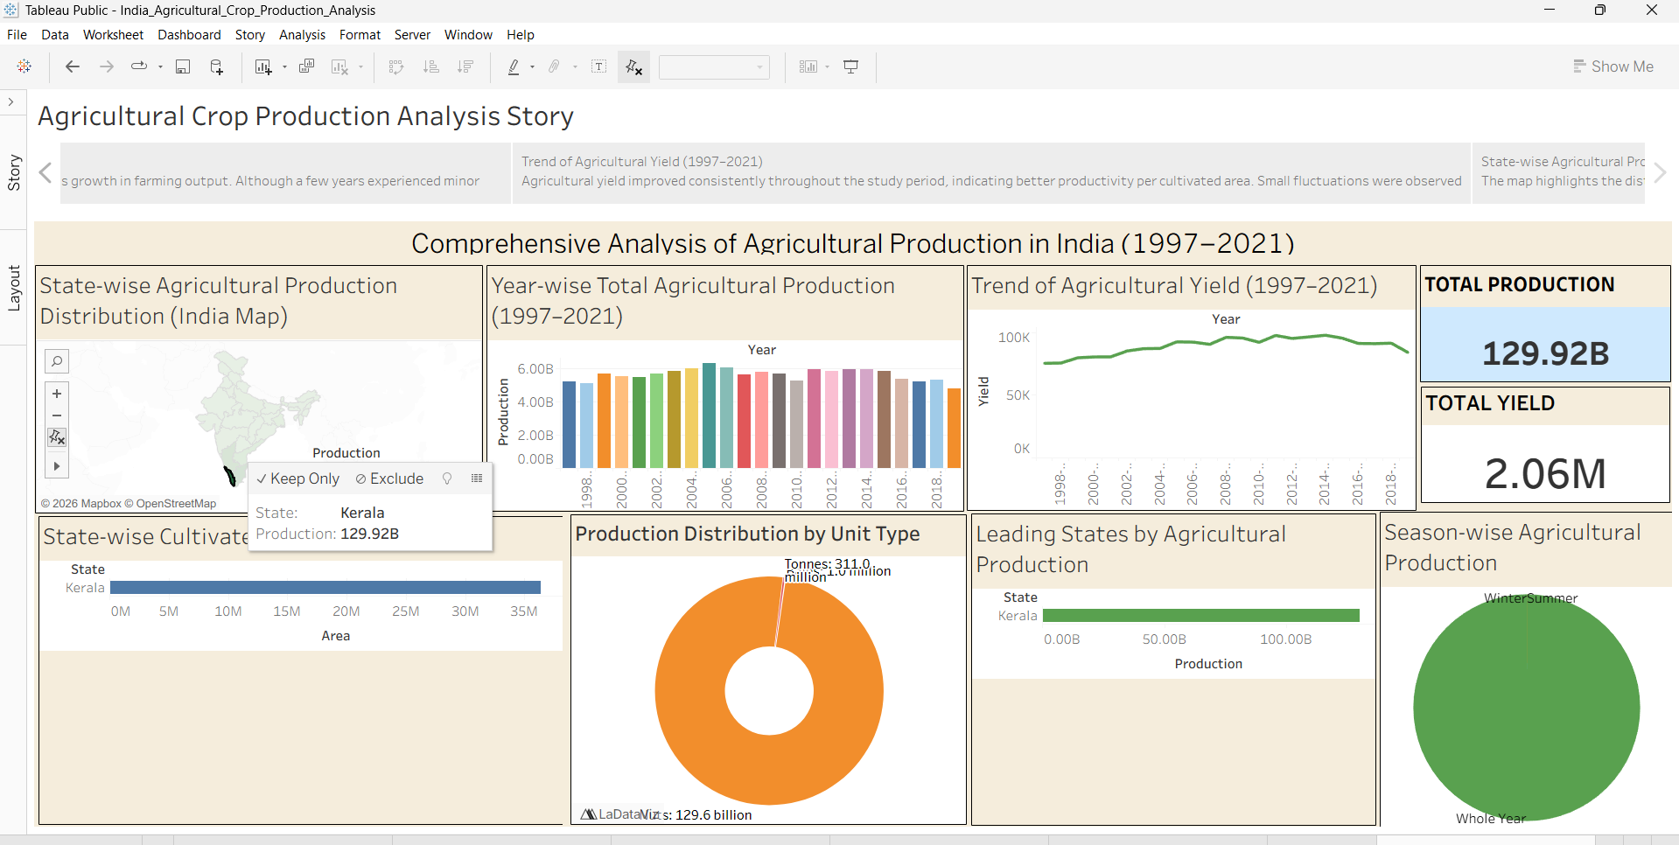
Figure 3: Dashboard action triggered by selecting Kerala on the India map, showing the Keep Only / Exclude options and Kerala's production tooltip.

8. India Map Development
The India map is the centerpiece of the dashboard and required the most care to build correctly, since Tableau does not always recognize Indian state names automatically.

Map Layers and State Boundaries
The map uses Tableau's built-in state-boundary layer for India, with each of the country's states and union territories outlined individually. State names in the dataset were matched against Tableau's geographic role for 'State/Province' so every polygon rendered without unknown or unplotted locations.

Color Encoding and Production Scale
Color is encoded on a single-hue green gradient tied to the Production measure, running from a light green (0.00B) to a dark green (129.92B), as shown in the legend. This lets a viewer instantly identify high-production states purely by how dark they appear, without needing to click into each one.

Tooltips and Interactivity
Hovering or clicking any state shows a tooltip with the exact state name and production value - for example the screenshot below shows Uttar Pradesh with a production figure of 4.58B. This gives an exact number to back up the visual color-based impression, and the same click also drives the dashboard action described on the previous page.

How Users Analyze State-wise Production
A user can scan the map for the darkest regions to spot leading states at a glance, hover over any state for its precise figure, or click a state to filter the entire dashboard down to that state's detailed breakdown - combining a quick visual overview with an exact-value drill-down in a single chart.
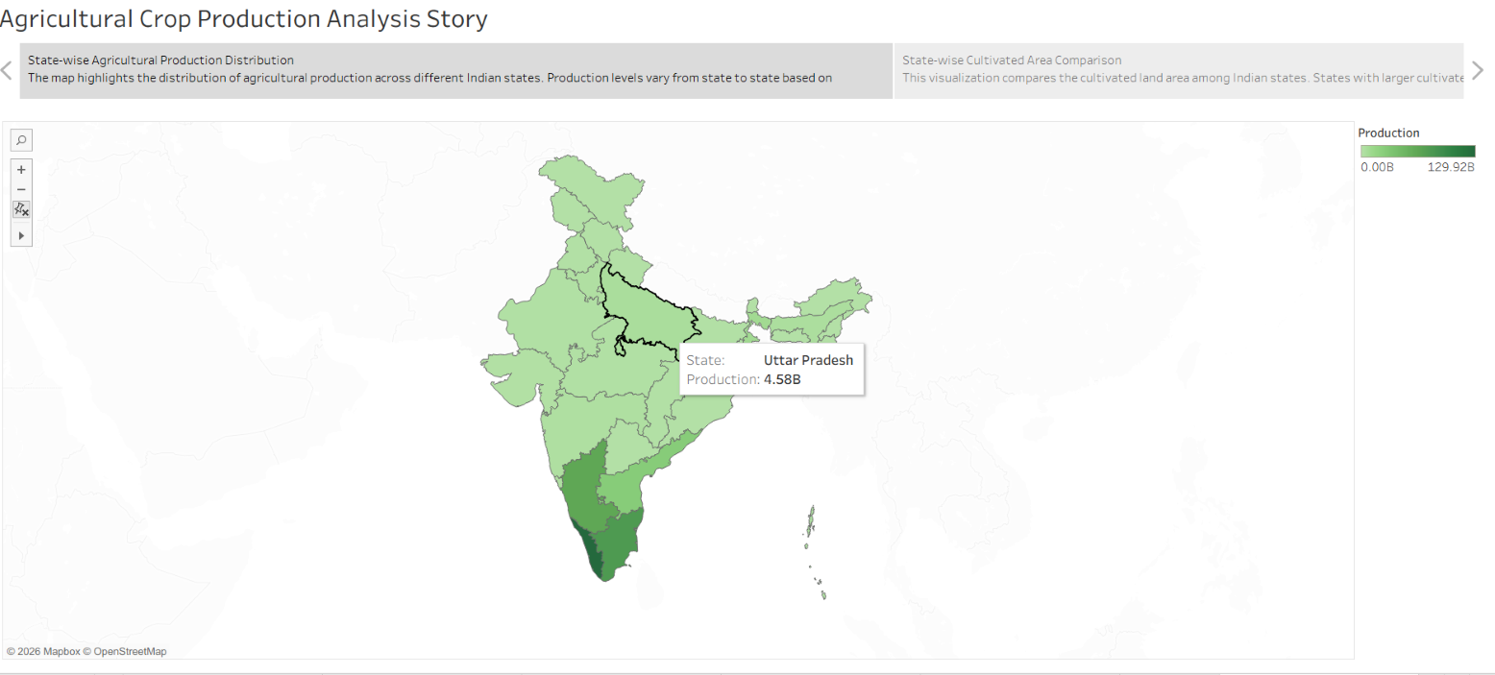
Figure 4: India map (Story view) showing Uttar Pradesh selected with a production tooltip of 4.58B.

9. Story Development

Purpose of the Tableau Story
Beyond the interactive dashboard, a Tableau Story titled 'Agricultural Crop Production Analysis Story' was built to guide a first-time viewer through the data in a logical sequence, rather than leaving them to explore nine charts with no starting point.

Navigation
The story uses Tableau's built-in navigator strip at the top, letting a viewer move forward and backward between story points using the arrow controls, or jump directly to a specific point by clicking its caption in the strip.

Story Points
Each story point captures one dashboard view along with a short caption summarizing the insight for that view - for example the state-wise production map is paired with a caption explaining that production levels vary state to state, and the cultivated area chart is paired with a caption comparing land area across states. This mirrors the two figures shown earlier in this document (Figures 3 and 4), which were both captured from within the Story interface.

Interactive Presentation
Because each story point is built on top of the live dashboard, the underlying charts remain interactive even while presenting - a viewer can still click a state within a story point and see the cross-filtering behavior described on Page 8, blending a guided narrative with hands-on exploration.

Each Story Point Represents One Business Insight
The story was structured so that every point answers one of the business questions defined on Page 5 - one point per insight, such as the state with highest production, the yield trend over time, or the leading contributing season - so that by the final story point, the viewer has been walked through the whole analysis end to end.

10. Publishing to Tableau Public

Publishing Steps
Once the dashboard and story were finalized, the workbook was published from Tableau Desktop using Server > Tableau Public > Save to Tableau Public, signing in with the team's Tableau Public account and naming the workbook 'India_Agricultural_Crop_Production_Analysis'.

Public URL
After publishing, Tableau Public generated a shareable public URL under the profile shaik.imamkhasim, in the format public.tableau.com/app/profile/shaik.imamkhasim/viz/India_Agricultural_Crop_Production_Analysis, which can be opened by anyone without needing a Tableau license.

Verification and Browser Testing
The published link was opened in a browser to confirm that the dashboard loaded correctly outside of Tableau Desktop - every KPI card, chart, and the India map rendered exactly as designed, and the dashboard action (clicking a state) was re-tested directly on the live public page to confirm it still worked after publishing.

Dashboard Accessibility
The published version is fully accessible online, requires no sign-in for viewers, and retains all interactivity - filters, dashboard actions, and story navigation - exactly as it behaves in Tableau Desktop.
The dashboard was successfully published to Tableau Public and verified as fully functional and accessible from a standard web browser, as shown below.
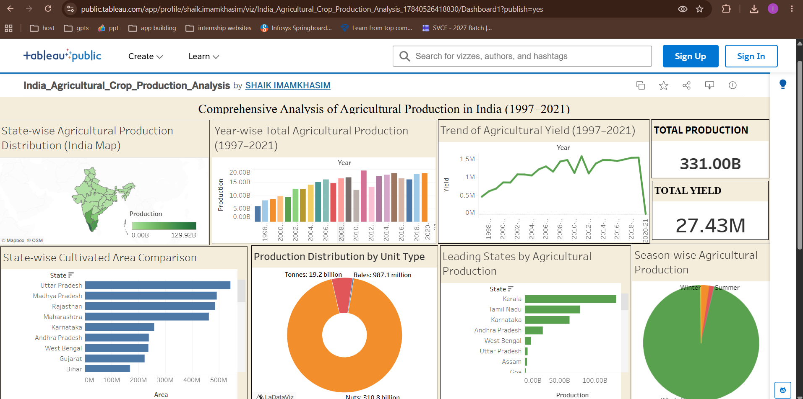
Figure 5: The dashboard live on Tableau Public, viewed in a browser at the published public URL.

11. Testing During Development

Dashboard Validation
The overall dashboard was checked at multiple stages of development to confirm every container resized correctly, no chart overlapped another, and all nine visualizations loaded without errors when the workbook was reopened.

KPI Validation
The Total Production and Total Yield KPI values were manually recalculated in Excel using SUM and AVERAGE formulas on the raw dataset and compared against the numbers shown on the KPI cards to confirm they matched exactly.

Map Validation
Every state in the dataset was checked against the India map to confirm it plotted in the correct location with no unrecognized or unplotted states, and tooltip values were spot-checked against the underlying data.

Chart Validation
Each of the seven supporting charts (bar, line, donut, and pie visualizations) was tested by comparing a handful of individual data points against manually filtered values in Excel to confirm the aggregations were correct.

Dashboard Actions Testing
The Keep Only / Exclude action was tested on multiple states, not just Kerala, to confirm that every chart on the dashboard updated consistently regardless of which state was selected.

Story Validation
Each story point was clicked through in sequence to confirm the correct dashboard view and caption appeared for that point, and that navigating backward and forward did not break any chart's interactivity.

Publishing Validation
After publishing, the team re-ran every test above directly on the Tableau Public page in a browser to confirm nothing broke during the publish step, since some local features occasionally behave differently once hosted online.

12. Challenges Faced

Data Cleaning
Challenge: Several district-level rows had missing or zero Production values that would have understated state totals. Solution: These rows were identified using Tableau's null-value indicators and Excel filters, then removed after confirming they were genuine gaps rather than valid zero-production records.

Map Configuration
Challenge: A few state names in the raw dataset did not initially match Tableau's built-in geographic role for India, leaving those states blank on the map. Solution: State names were manually corrected to match Tableau's expected naming (for example fixing inconsistent capitalization and spacing) until every state plotted correctly.

Dashboard Alignment
Challenge: Charts of different sizes initially left uneven gaps between containers, making the dashboard look unbalanced. Solution: Fixed-width horizontal and vertical containers were used instead of floating objects, which forced every chart to resize proportionally and kept the layout aligned.

Color Selection
Challenge: The first color palette used bright, mismatched colors across charts that made the dashboard feel cluttered. Solution: The palette was narrowed down to a consistent cream-and-green theme across all charts, which matched the agricultural subject matter and made the dashboard easier to read.

Dashboard Actions
Challenge: The first version of the filter action affected the map itself, which caused other states to disappear entirely instead of just being de-emphasized. Solution: The action was reconfigured to exclude the source sheet (the map) from the target list, so the map keeps showing every state while only the supporting charts filter down.

Publishing
Challenge: An early publish attempt failed because the workbook referenced a local Excel file that Tableau Public could not access online. Solution: The data source was set to an extract (a saved copy of the data embedded in the workbook) before publishing, which resolved the dependency and let the dashboard load correctly for any online viewer.

13. Project Outcomes

Skills Learned
- Connecting and cleaning real-world Excel data for use in Tableau.
- Building calculated fields (SUM, AVG) to power KPI cards and measures.
- Configuring a geographic map visualization with color-encoded production data.
- Setting up dashboard actions for cross-filtering between charts.
- Designing a multi-chart dashboard layout using containers for consistent alignment.
- Building a Tableau Story to present findings in a guided, business-friendly narrative.
- Publishing and verifying a workbook on Tableau Public.

Knowledge Gained
Beyond the technical Tableau skills, the team gained a clearer understanding of how Indian agricultural production and yield have evolved over more than two decades, which states dominate national output, and how seasonal patterns shape total production.

Dashboard Quality
The final dashboard combines a clean, uncluttered layout with genuinely useful interactivity, meeting the goal of presenting nine distinct visualizations on a single screen without overwhelming the viewer.

Interactive Analytics and Real-time Decision Support
Because every chart is linked through the dashboard action, a user exploring the dashboard - whether a student, a policymaker, or an agri-business analyst - can move from a national overview to a specific state's detailed picture in seconds, supporting faster, more informed decisions than a static report would allow.

Benefits
The project demonstrates, in a compact and practical form, how a well-designed Tableau dashboard can turn 24 years of raw agricultural records into an accessible tool for spotting trends, comparing states, and communicating insights to a non-technical audience.

14. Development Summary
The project moved through a clear, structured development process - starting with dataset collection and cleaning, moving through individual chart development, dashboard assembly, interactivity via dashboard actions, story creation, and finally publishing to Tableau Public. Each stage was tested before moving to the next, which kept errors from compounding as the dashboard grew more complex.

Project Success
The finished dashboard successfully brings together nine visualizations - two KPI cards, an interactive India map, and six supporting charts - into one interconnected view, published and verified as fully functional on Tableau Public.

Objectives Achieved
- An interactive, single-screen dashboard summarizing 1997-2021 agricultural data was delivered.
- State, year, season, and crop-level exploration is possible without any coding by the viewer.
- Key patterns - leading states, seasonal contribution, and yield trends - are visible at a glance.
- Real Tableau development skills were practiced end-to-end within a genuine internship deliverable.
- The dashboard was published and confirmed accessible to anyone with the shared link.

Learning Experience
Working as a three-member team on a shared Tableau workbook taught the group how to divide chart-building work while keeping a single, consistent dashboard design, and how much iteration is genuinely needed to get colors, layout, and interactivity feeling polished rather than just functional.

Future Improvements
- Adding a crop-level drill-down so a user could filter by individual crop, not just state and season.
- Including year-over-year growth-rate calculations alongside the raw production figures.
- Extending the dataset beyond 2021 as newer agricultural records become available.

Conclusion
Overall, the India's Agricultural Crop Production Analysis dashboard met every objective set out at the start of the project: it is interactive, visually clear, published, and genuinely useful for exploring more than two decades of Indian agricultural data. The experience strengthened the team's practical Tableau skills and gave a solid foundation for tackling larger analytics projects in the future.

